**Day # 3 Assignments**

**Task / Problems**:

1. List the various categories and count of books in each category.

SELECT category, COUNT(*) AS book_count

FROM books

GROUP BY category;

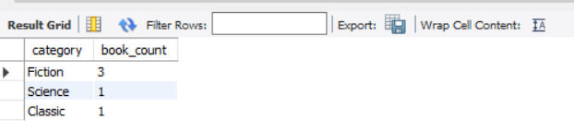

**-- 2) List the book_No and the number of times the book is issued in the descending order of count.**

SELECT book_no, COUNT(*) AS issue_count

FROM issue

GROUP BY book_no

ORDER BY issue_count DESC;

**-- 3) Find the maximum, minimum, total and average cost amount in the books table.**

SELECT MAX(cost) AS max_cost_amount FROM books;

SELECT MIN(cost) AS min_cost_amount FROM books;

SELECT SUM(cost) AS total_cost_amount FROM books;

SELECT AVG(cost) AS avg_cost_amount FROM books;

-- 4) Display the member id and the no of books for each member that has issued more then 2 books.

SELECT member_id, COUNT(*) AS issued_books_count

FROM issue

GROUP BY member_id

HAVING issued_books_count > 2;

-- 5) Display the member id, book no and no of times the same book is issued by the member in the descending order of count.

SELECT member_id, book_no, COUNT(*) AS issue_count

FROM issue

GROUP BY member_id, book_no

ORDER BY issue_count DESC;

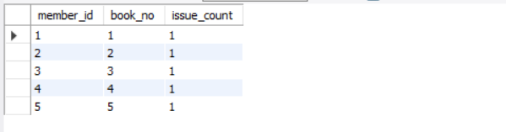

-- 6) Display the month and no of books issued each month in the descending order of count.

SELECT DATE_FORMAT(issue_date, '%Y-%m') AS issue_month, COUNT(*) AS books_issued_count

FROM issue

GROUP BY issue_month

ORDER BY books_issued_count DESC;

-- 7) List the book_no of all the books that are not issued to any member so far.

SELECT b.book_no

FROM books b

LEFT JOIN issue i ON b.book_no = i.book_no

WHERE i.book_no IS NULL;

-- 8) List all the member id that exist in member table and has also at least one book issued by them.

SELECT DISTINCT m.member_id

FROM member m

INNER JOIN issue i ON m.member_id = i.member_id;

-- 9) List the member ID with highest and lowest no of books issued.

SELECT member_id, COUNT(*) AS issued_books_count

FROM issue

GROUP BY member_id

ORDER BY issued_books_count DESC

LIMIT 1; -- Highest

UNION

SELECT member_id, COUNT(*) AS issued_books_count

FROM issue

GROUP BY member_id

ORDER BY issued_books_count ASC

LIMIT 1; -- Lowest



-- 10) List all the Issue_details for books issued in December and July without using any arithmetic, Logical or comparison operator.

SELECT *

FROM issue

WHERE MONTH(issue_date) IN (12, 7);

-- 11) List the Book_No, Book_Name and Issue_date for all the books that are issued in month of December and belong to category Database.

SELECT b.book_no, b.book_name, i.issue_date

FROM books b

INNER JOIN issue i ON b.book_no = i.book_no

WHERE MONTH(i.issue_date) = 12

AND YEAR(i.issue_date) = YEAR(CURRENT_DATE()) -- This year's December

AND b.category = 'Database';

-- 12) List the Member Id, Member Name and No of books Issued in the descending order of the count.

SELECT m.member_id, m.member_name, COUNT(i.book_no) AS books_issued_count

FROM member m

LEFT JOIN issue i ON m.member_id = i.member_id

GROUP BY m.member_id, m.member_name

ORDER BY books_issued_count DESC;

